Unit 2 questions

Deadline: by the class on Thursday (September 11th)

Instructions:
- Answer all questions in this file and upload it back.
- You may use any materials and tools.
- Give brief and clear justification.
- Total: 10 points

Enjoy!

1. (1 point) Question 2.1: Choose the correct answer(s)
Figure 2.1 shows an index of average real wages of skilled workers in London between 1264 and 2001. What can we conclude from this graph?
- 1.Skilled workers were paid about £100 in 1408.
- 2.The average wage in 1850 was about the same as that in 1408 in money terms (pounds received by the workers).
- 3.The average real wage was more or less constant between 1264 and 1850.
- 4.The average real wage increased by approximately 500–600% between 1850 and 2001.
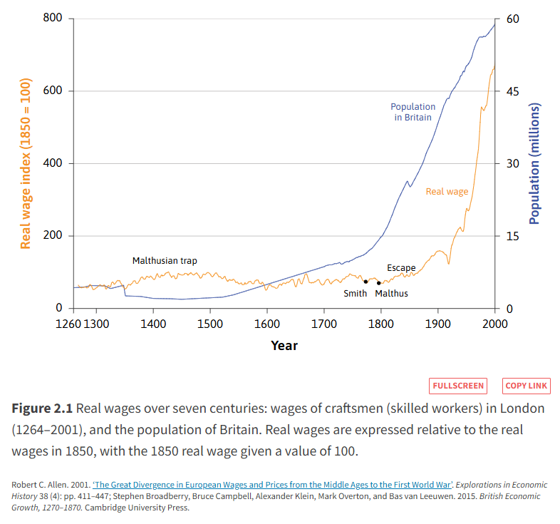

2. (2 points) Exercise 2.2: Opportunity costs
The British government introduced legislation in 2012 that gave universities the option to raise their tuition fees. Most chose to increase annual tuition fees for students from £3,000 to £9,000.
Does this mean that the cost of going to university has tripled? (Think about how the answer to this question might differ depending on whether you take an accounting perspective or an economic perspective.) To simplify, assume that the tuition fee is an ‘out-of-pocket’ cost, and ignore student loans.
Please write your answer here…

3. (3 points) Exercise 2.3: Apples and wheat
In the case of Carlos and Greta described in Figure 2.2a, Figure 2.2b, and Figure 2.2c, suppose that market prices were such that 35 apples could be bought for 1 ton of wheat.
- If Greta sold 16 tons of wheat, would both she and Carlos still be better off?
- What would happen if only 20 apples could be bought for the price of a ton of wheat?
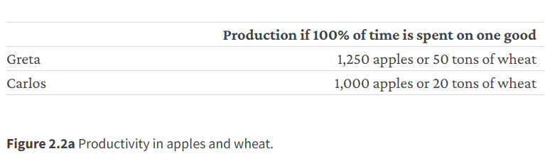
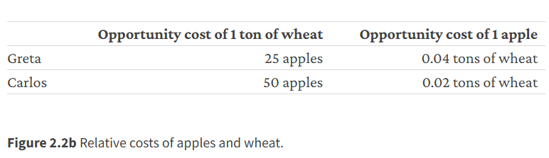
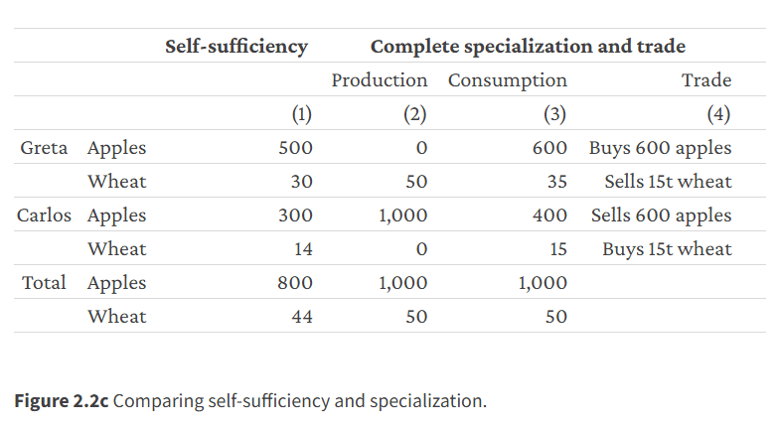
Please write your answer here…

4. (1 point) Question 2.5: Choose the correct answer(s)
Figure 2.4 shows the input requirements for different amounts of olive oil, for two technologies (A and B). Suppose there is a third fixed-proportions technology, C, which requires four workers and 360 units of energy to produce 100 litres of olive oil. Based on this information, read the following statements and choose the correct option(s).
- 1.Producing 300 litres of olive oil with technology C would require 12 workers and 1,080 units of energy.
- 2.The average product of labour of technology C is between that of technology A and B.
- 3.The energy–labour ratio of technology C is between that of technology A and B.
- 4.The owner of the firm would prefer technology B over technology C.
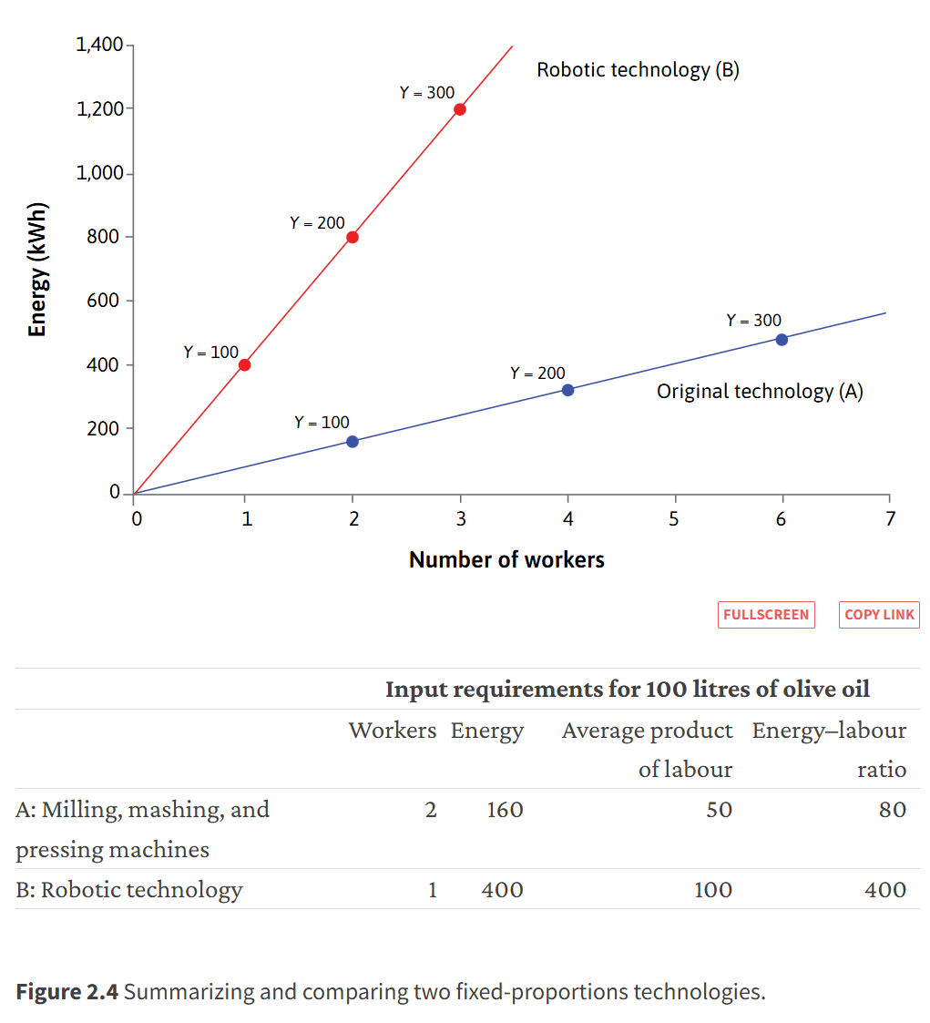

5. (1 point) Question 2.6 Choose the correct answer(s)
Figure 2.6 shows different technologies for producing 100 metres of cloth.
Based on this information, what can we conclude?
- 1.Technology D is more energy-intensive than technology C.
- 2.Technology B dominates technology D.
- 3.Technology A is the cost-minimizing technology at all prices of coal and wages.
- 4.Technology C can sometimes be a cheaper technology than A.
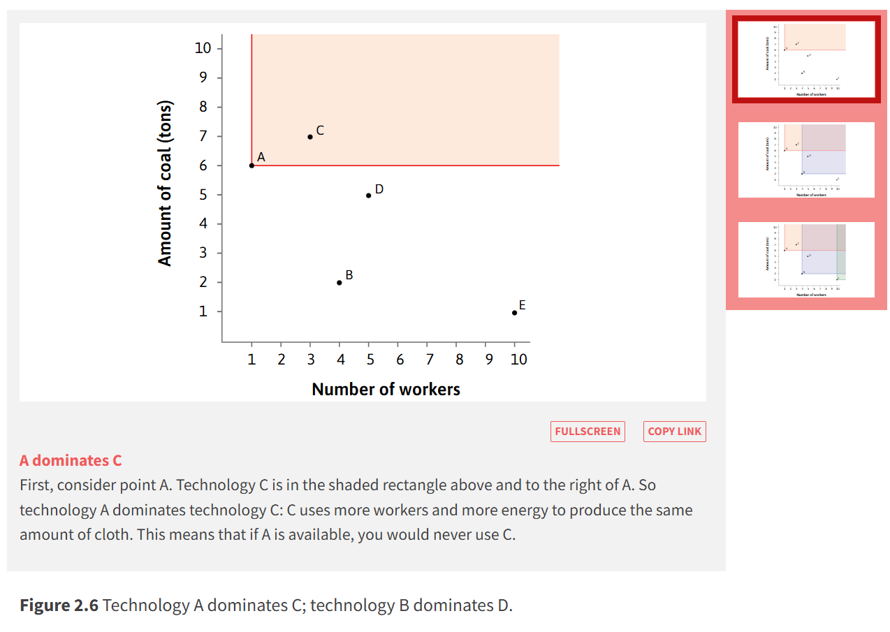
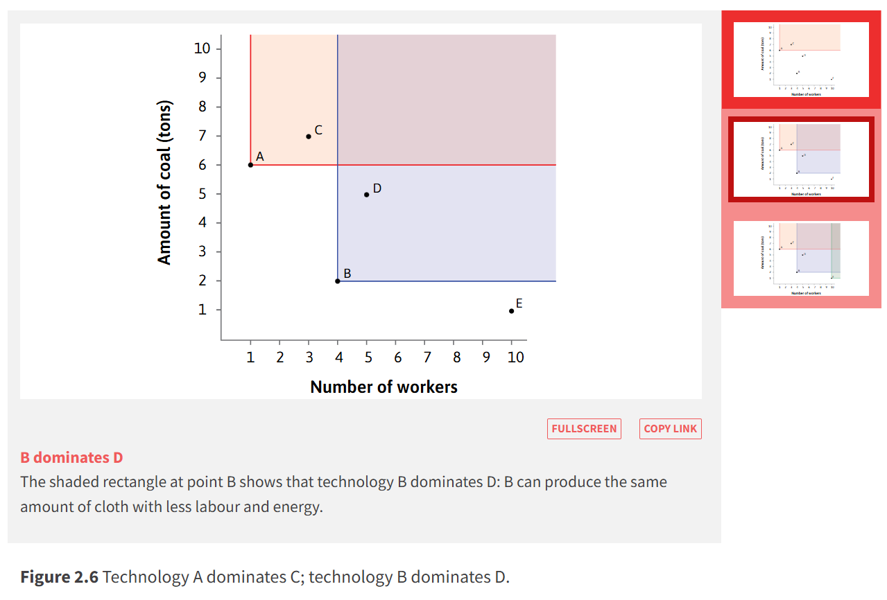
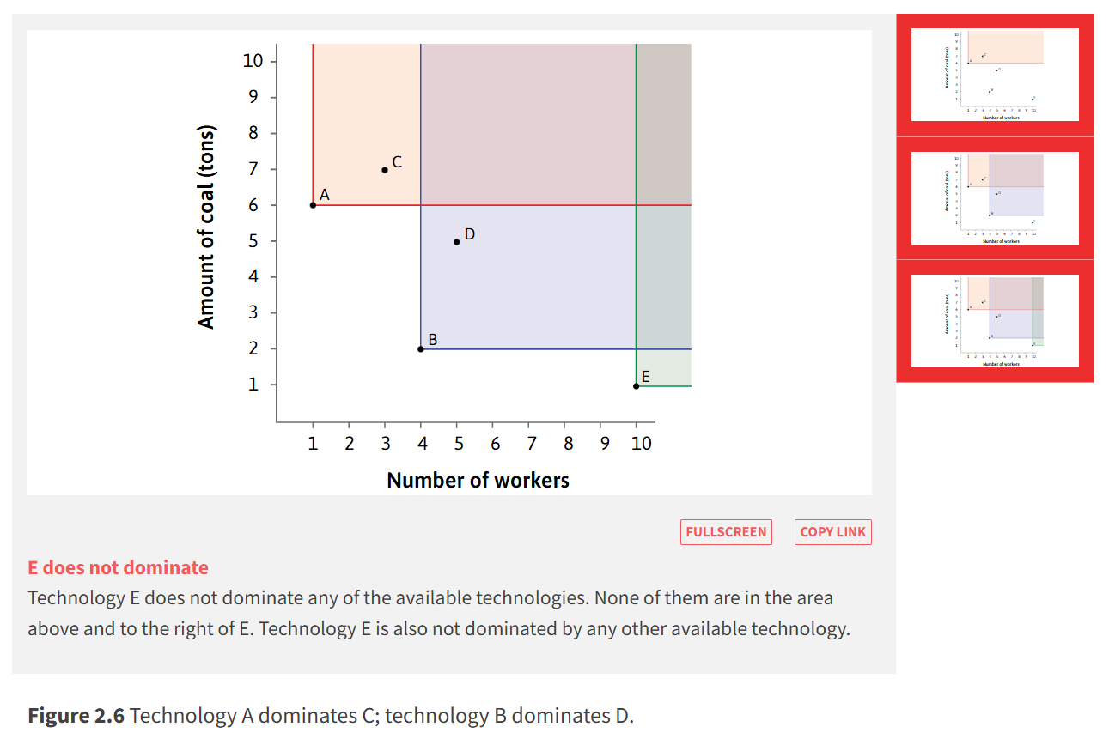

6. (2 points) Exercise 2.9 Designing a model
For a country (or city) of your choice, find a map of the railway or public transport network.
Much like economic models, maps are simplified representations of reality. They include relevant information, while abstracting from irrelevant details.
- How do you think the designer selected which features of reality to include in the map you have selected?
- In which way is a map not like an economic model?

Please write your answer here…

